**EVENTIX – ONLINE TICKET BOOKING WEBSITE**

Name: Asylbek Abdibay

Group: SE-2427

For this assignment, I developed Eventix, a complete online ticket booking platform that allows users to:

Browse upcoming events

Filter events by category and date

Add tickets to a shopping cart

Modify cart (quantity, remove items)

Complete a secure checkout process

Contact support via form and map

This is my project report for the Eventix ticket website. I made 5 pages, used Bootstrap, jQuery, and localStorage. Below are screenshots from the live site and code as required.

1. HOME PAGE – LIVE SITE



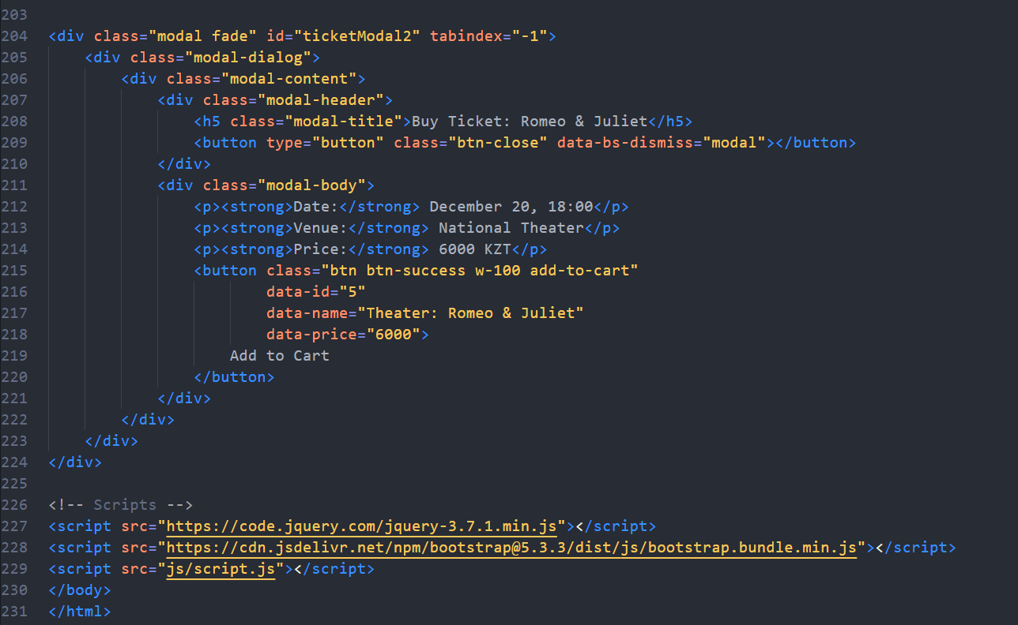



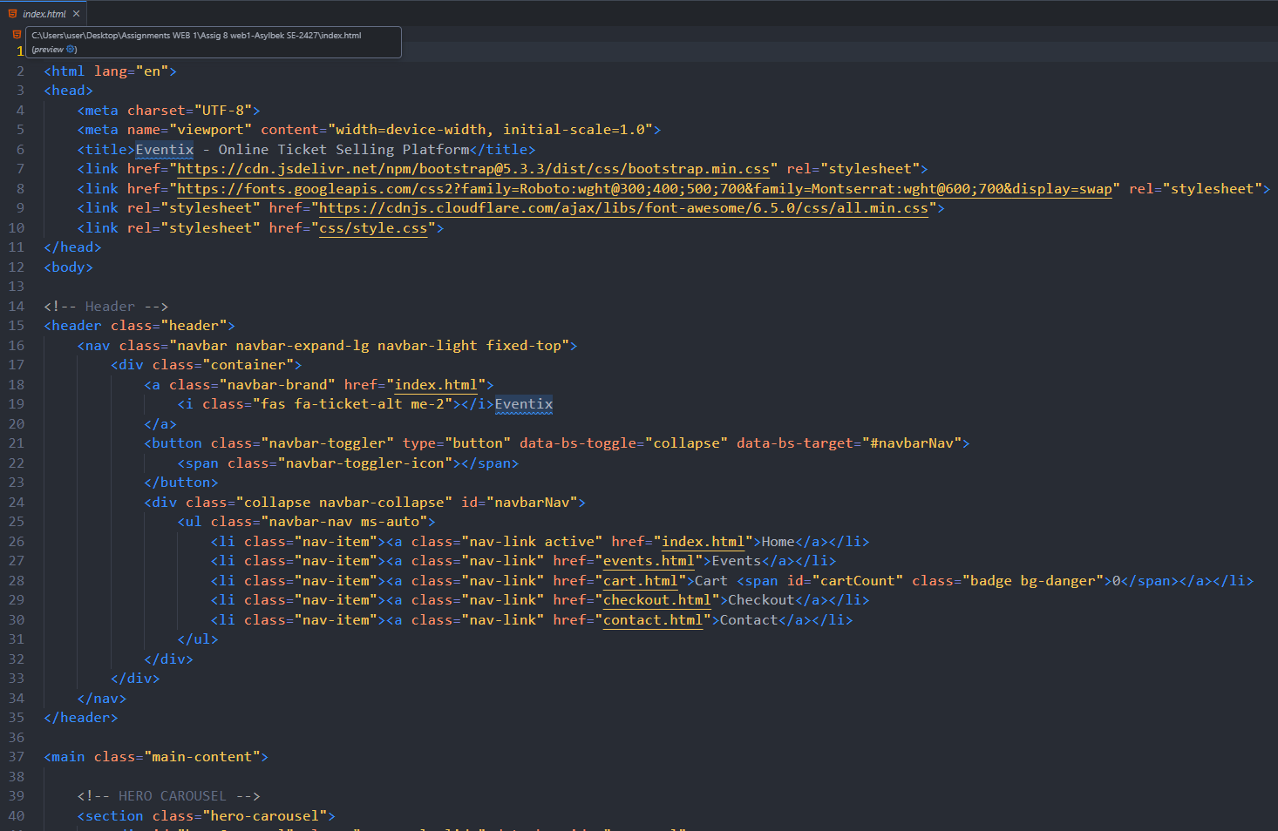

2. TECHNICAL IMPLEMENTATION

2.1 Technologies Used

HTML5 – Semantic structure

Bootstrap 5 – Responsive grid, navbar, carousel, forms

CSS3 (custom) – Styling, animations, hover effects

JavaScript – Logic, filters, cart math

jQuery – Animations, event handling

localStorage – Persistent cart

Font Awesome – Icons

Google Fonts – Typography

2.2 Project Structure

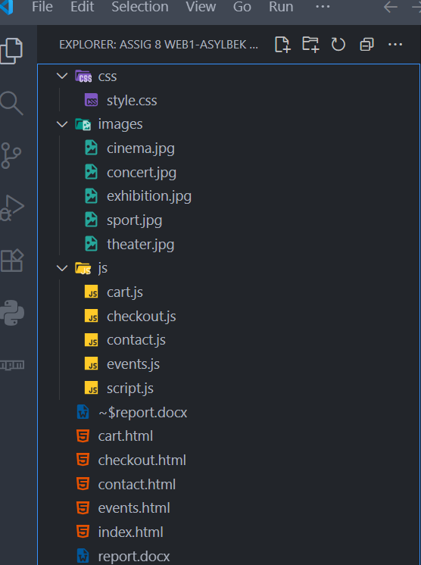

3. PAGE-BY-PAGE BREAKDOWN WITH SCREENSHOTS

3.1 HOME PAGE (index.html)

Bootstrap Carousel: Auto-slides every 5 seconds

jQuery Animation: "Add to Cart" turns green + "Added!" for 1 second

Fixed: Features section was hidden under carousel → removed margin-bottom: -80px

Fade-in effect on event cards using jQuery + CSS

3.2 EVENTS PAGE (events.html)

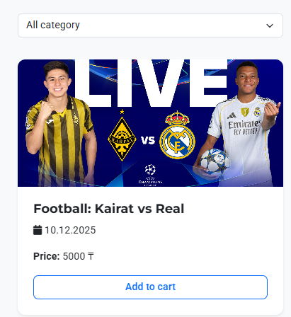

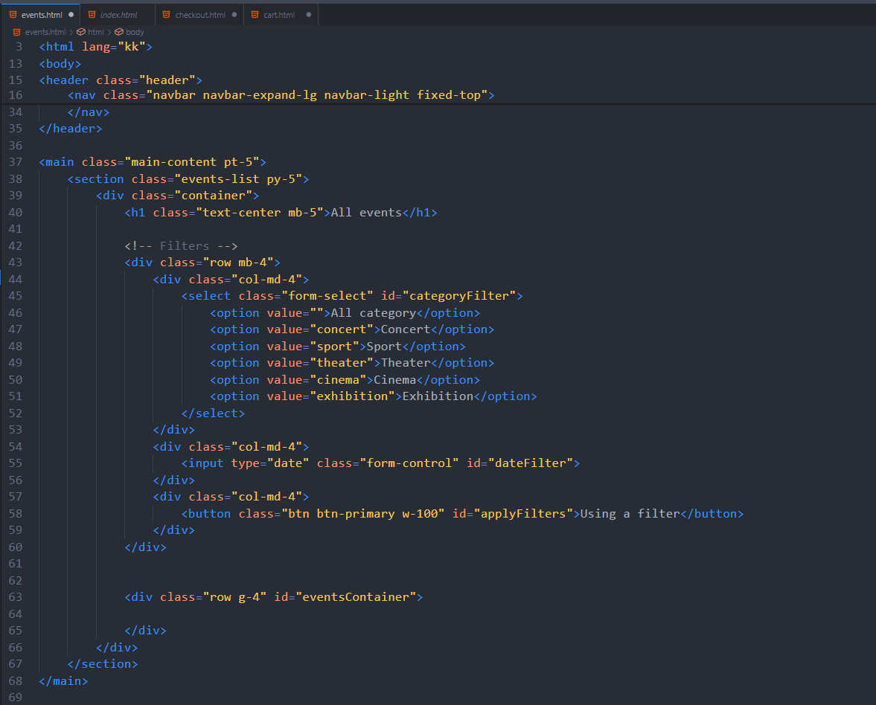

Dynamic Rendering: Events loaded from JS array

Filter System: Category + Date using filter()

Slide-up Animation: Cards appear with jQuery + CSS

Add to Cart: Updates localStorage

3.3 CART PAGE (cart.html)

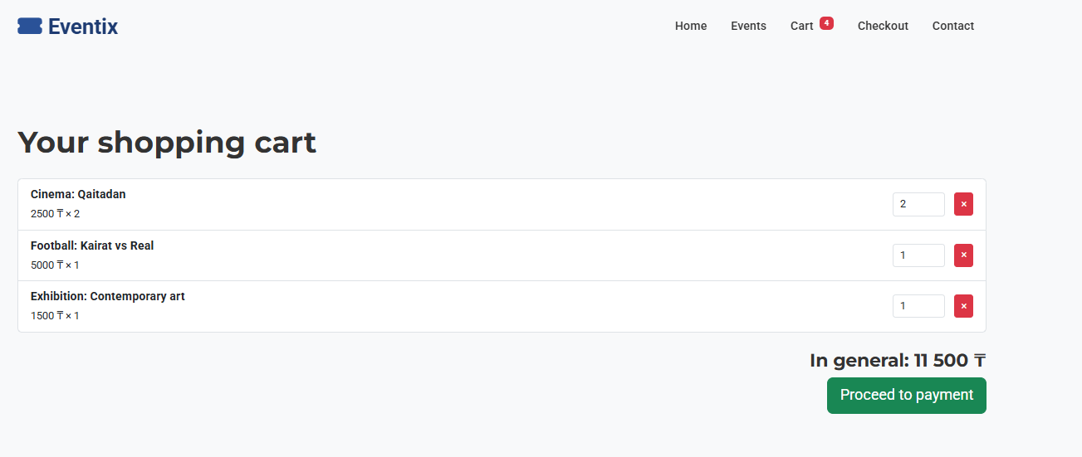

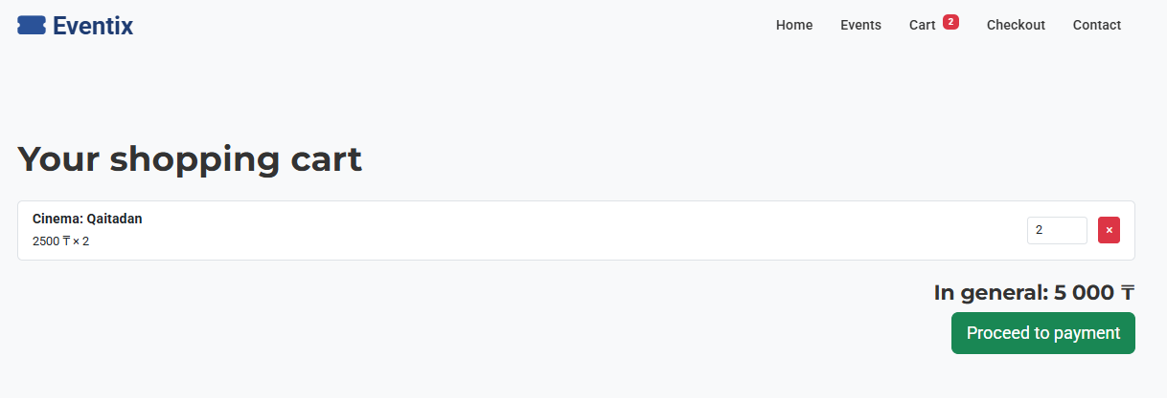

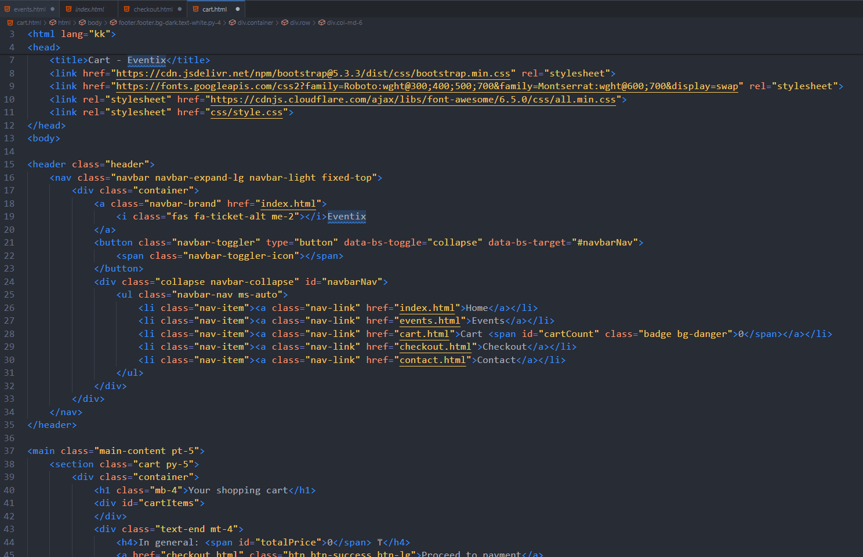

Real-time Updates: Change quantity → total recalculates

Remove Item: Click × → filter() removes from array

Event Delegation: $(document).on() for dynamic buttons

Price Formatting: toLocaleString() → 5,000 KZT

3.4 CHECKOUT PAGE (checkout.html)

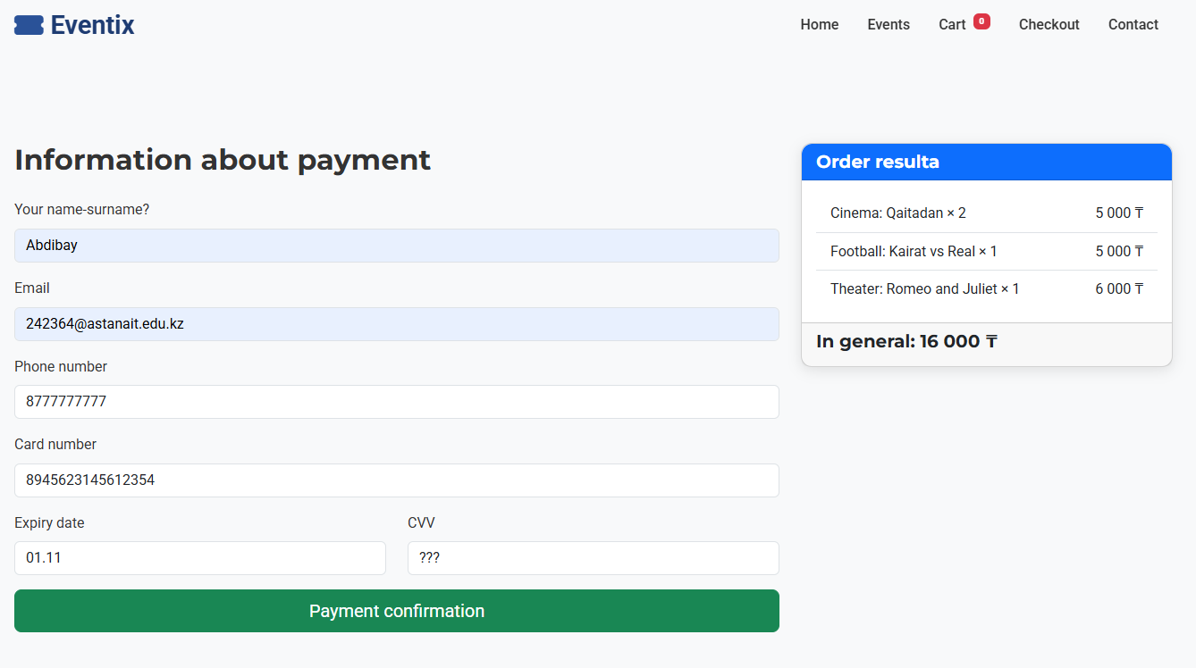

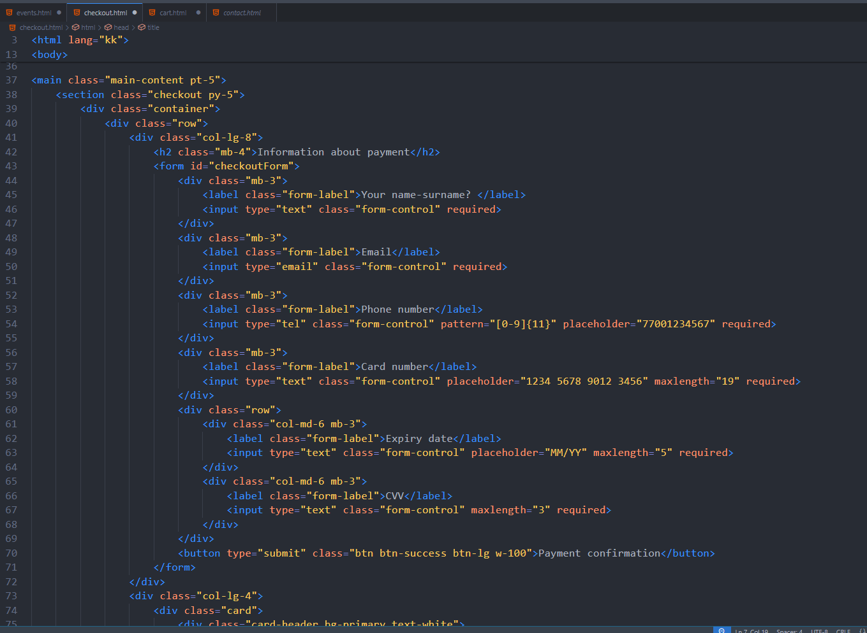

Bootstrap Validation: Email, phone, card number checked

jQuery Animation: fadeOut() → full success page

localStorage Cleared: Cart reset after purchase

3.5 CONTACT PAGE (contact.html)

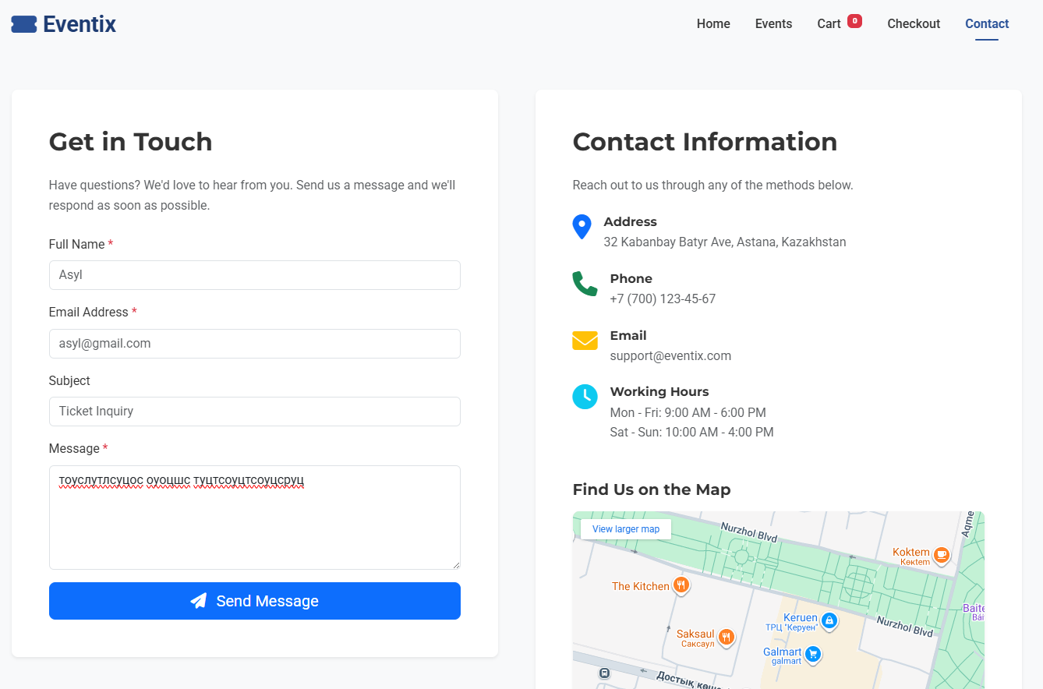

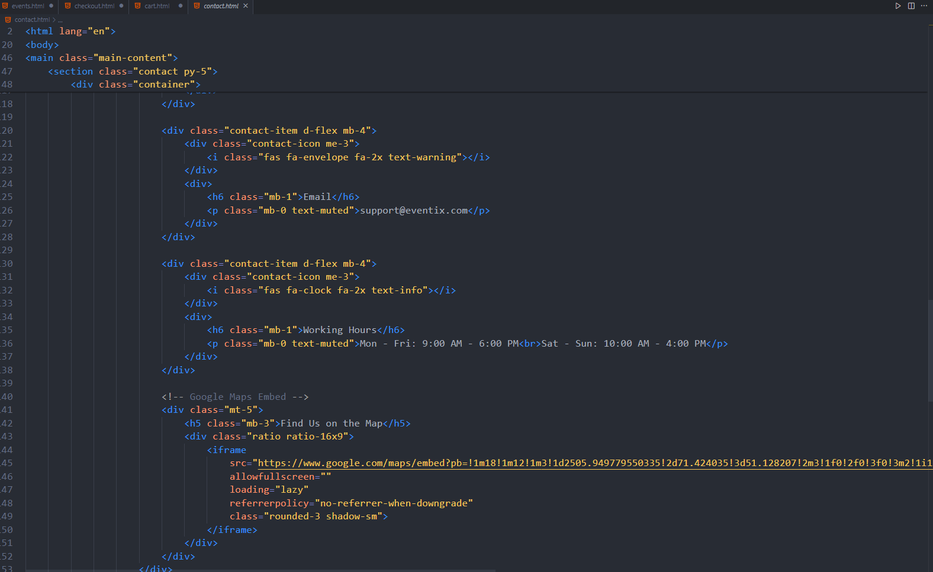

Form Validation: Required fields

jQuery Effects: Form fades out → success message fades in

Google Maps Embed: Astana IT University

Responsive Layout: 2-column on desktop, 1-column on mobile

4. KEY CODE IMPLEMENTATIONS (VS Code Screenshots)

4.1 localStorage – Add to Cart (js/script.js)

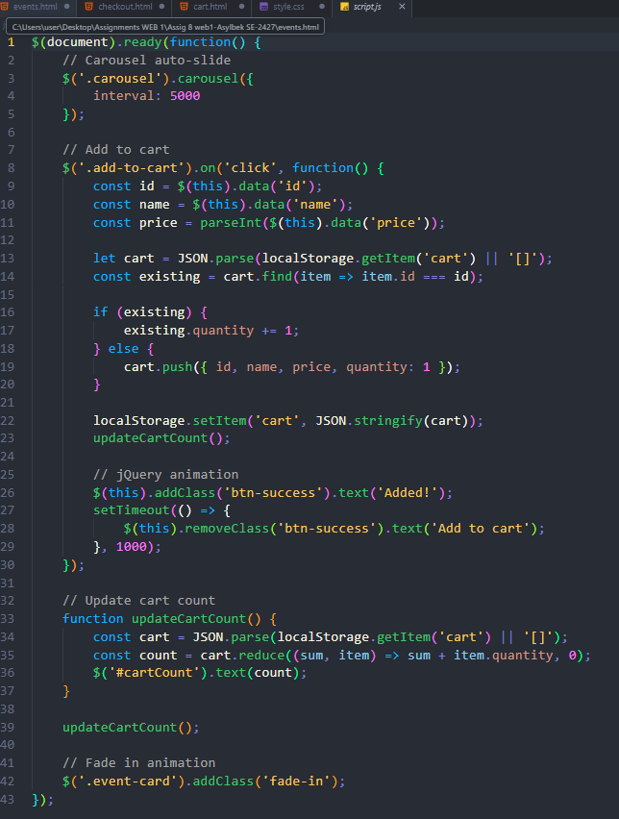

4.2 jQuery Button Animation (js/script.js)

$(this).addClass('btn-success').text('Added!');

setTimeout(() => {

$(this).removeClass('btn-success').text('Add to Cart');

}, 1000);

4.3 Filter Logic (js/events.js)

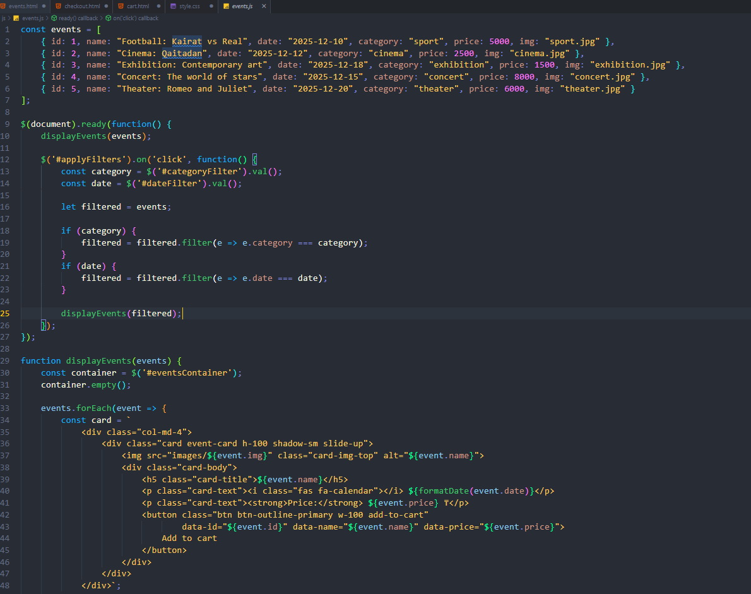

let filtered = events;

if (category) filtered = filtered.filter(e => e.category === category);

if (date) filtered = filtered.filter(e => e.date === date);

displayEvents(filtered);

contact.js

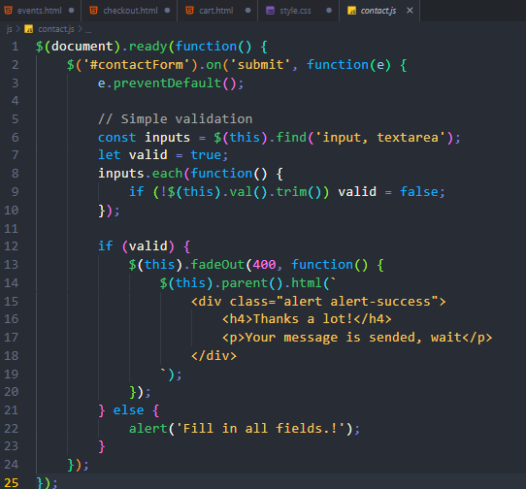

Checkout.js

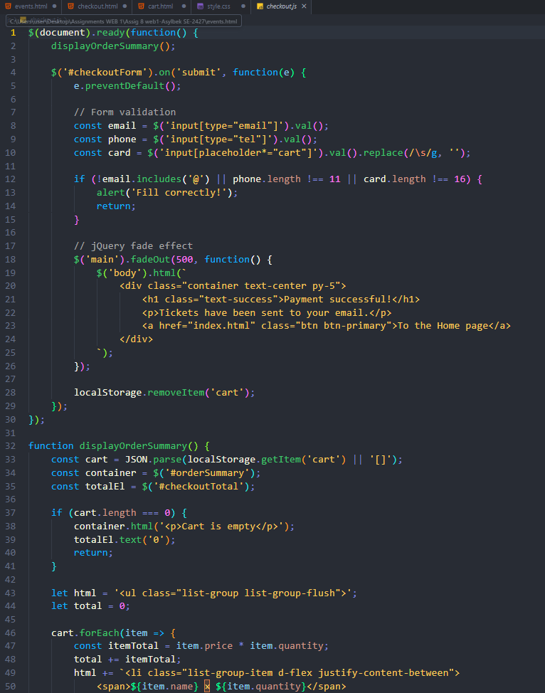

Cart.js

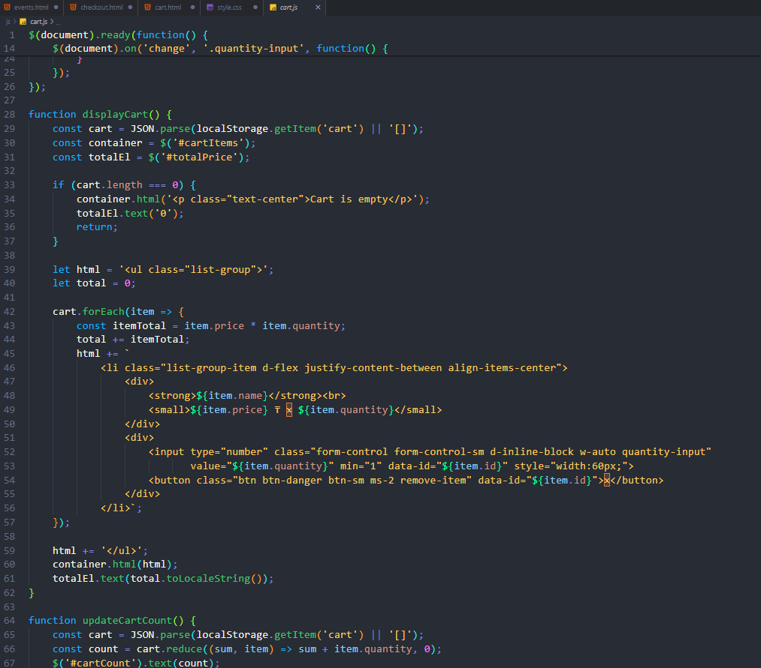

4.4 CSS Fix – Visible Navbar (css/style.css)

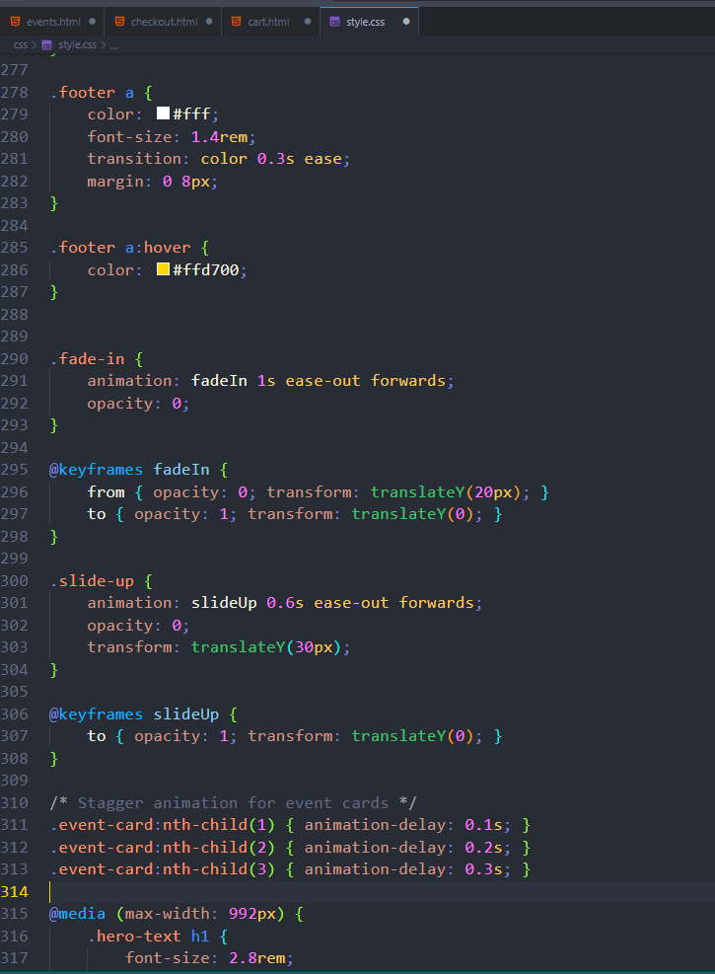

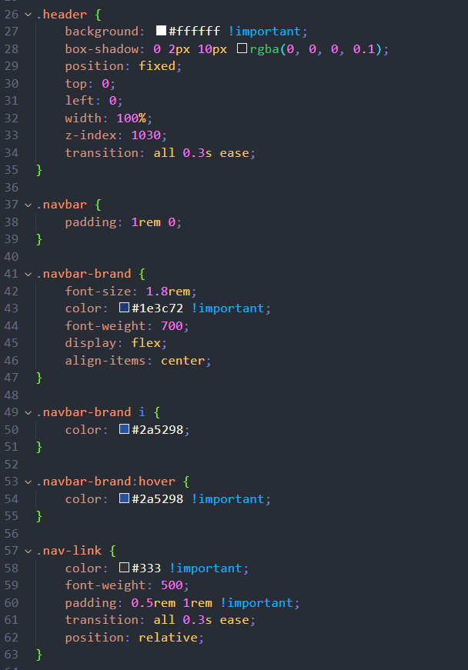

5. EVENT DATA (Updated)

Football: Kairat vs Real Madrid – Dec 10, 20:00 – Almaty Central Stadium – 5,000 KZT

Movie: "Freedom Again" – Dec 12, 19:00 – Kinopark Esentai – 2,500 KZT

Exhibition: "Modern Art" – Dec 18–25 – National Museum – 1,500 KZT

Concert: "Star World" – Dec 15, 19:00 – Astana Arena – 8,000 KZT

Theater: "Romeo & Juliet" – Dec 20, 18:00 – National Theater – 6,000 KZT

6. IMAGES

All images from Pexels.com (royalty-free). Resolution: 1920×1080+. Files: concert.jpg, theater.jpg, sport.jpg, cinema.jpg, exhibition.jpg

7. WORK PROCESS SUMMARY

1. Set up Bootstrap 5 and created 5 HTML pages

2. Designed responsive navbar – fixed visibility issue

3. Built hero carousel – fixed overlap with Features section

4. Implemented event cards on home page

5. Created dynamic Events page with filters and animations

6. Developed cart system using localStorage

7. Added checkout with form validation and success animation

8. Built contact form with Google Maps

9. Updated event names: Kairat, Freedom Again

10. Tested on mobile, tablet, desktop

11. Fixed all bugs (navbar, overlap, responsiveness)

12. Prepared report with live site + code screenshots

8. TESTING & COMPATIBILITY

Browsers: Chrome, Firefox, Edge, Safari

Devices: iPhone (375px), iPad (768px), Laptop (1920px)

Tools: Chrome DevTools (Responsive Mode)

Issues: None – no console errors

Cart Persistence: Works after refresh

Animations: Smooth on all devices

9. CONCLUSION

This project fully meets all requirements:

5+ HTML pages

Bootstrap 5 + Custom CSS

Fully responsive design

jQuery animations and effects

JavaScript interactivity (filters, cart, localStorage)

Semantic HTML and accessibility

No visual bugs

Updated event data

Professional, clean code

I learned a lot about localStorage, jQuery animations, and responsive debugging. The site feels like a real ticket platform.